Unit 10 Study Guide: Genetics, Variation & Natural Selection Name: ____________________________________Per._____

Lesson 10.1 Study Guide: The Work of Gregor Mendel: (Read ch. 10.1; pgs. 286-290)

- Define Genetics:
The scientific study of biological inheritance

- A ‘model system’ is using an organism that is convenient to study and may help learn about other species.
Why were pea plants a model system for Mendel to use in studying genetics?
Easy to grow and produce hundreds of offspring (undergo sexual reproduction)

- Pea plants are “true breeding”, which means they are self-pollinating. What do true-breeding plants' offspring look like?
Produce offspring with traits identical to themselves

- Define Trait:
A specific characteristic for an organsism

- Mendel used the process of cross-pollination to learn how traits are determined. Describe the process of cross-pollination process:
Prevented self-pollination by cutting away male pollen parts and dusting pollen onto different plants

- Cross-pollination resulted in hybrids. Define Hybrid:
Offspring where the parents have different contrasting characteristics. The offspring are mix of both parents

Use the definition from the textbook to explain what a hybrid vehicle is.
A hybrid is has gas powered and battery powered capabilites
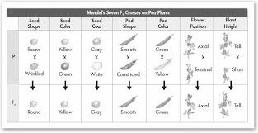

- On the diagram above, Circle or Highlight the row Mendel used to study how traits are determined.(Use Figure 10-2 on text pg. 288 – READ the Caption too.)

Genes and Alleles
- Describe the resulting offspring (F₁) of Mendel’s parental (P) cross:
The offspring had characteristics of only one of its parents. The other trait seemed to have disappeared.

- Define Genes AND give an example of genes from Mendel’s peas:
Sequence of DNA that codes for a protein and therefore determines a trait = a factor that is passed from parents to
offspring. Example: Seed color, seed shape, etc...

- Define Alleles AND give an example of dominant and recessive alleles from Mendel’s peas:
Different forms of a single gene. Example: Round is dominant; wrinkled is recessive

- What were Mendel’s 2 conclusions from his experiments?
  - An individual's characteristics are determined by factors that are passed from parents to offspring.

  - Principle of dominance: some alleles are dominant, some are recessive

Segregation
- As all good scientists do, Mendel had more questions from his experiments. How did Mendel test his next question, “Had the recessive alleles simply disappeared or were they still present in the new plants?”
He allowed all seven kinds of F1 hybrids to self-pollinate to produce an F2 generation

- What was the remarkable discovery made by Mendel as he looked at the F₂ generation?
Traits produced by recessive alleles (that disappeared in F1) reappeared in the F2 generation
- What does it mean for alleles to segregate AND when does segregation occur?
Segregation is when the alleles for a single gene separates from each other. This happens during gamete formation
(meiosis)

Visual Reading Tool: Segregation Read pg.290 and use figure 10-4 to answer the questions below:
- How do biologists represent dominant alleles? _By using a capital letter__ recessive alleles? _By using a lowercase letter__

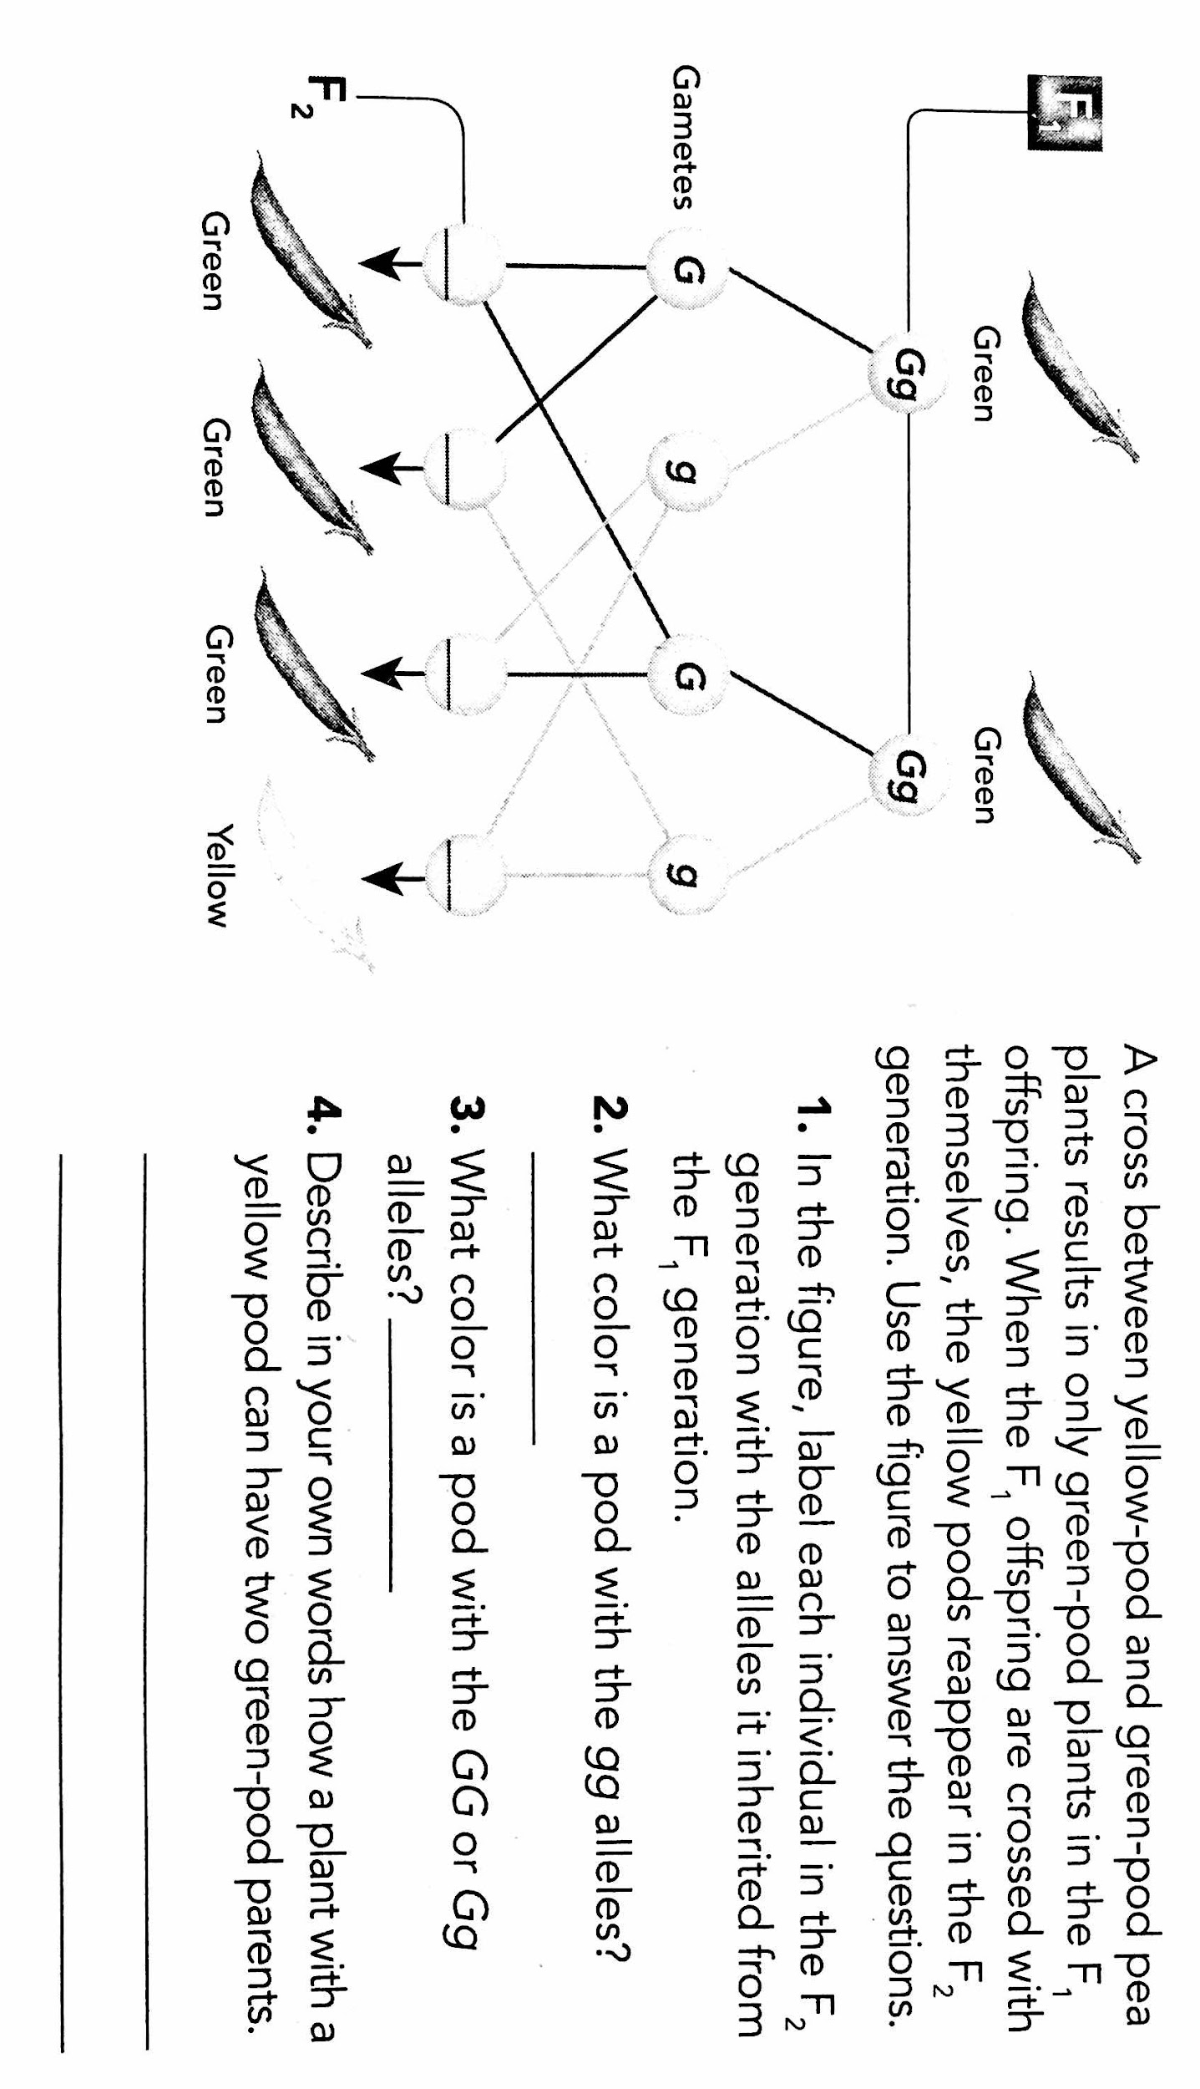
A
B
C
D
A cross between yellow-pod and green-pod pea plants results in ONLY green-pod plants in the F1 offspring. When the F1 offspring are crossed with themselves, the yellow pods reappear in the F2 generation. Use the figure to the right to answer the following.

16. Write each individual (A-D) in the F2 generation with the alleles it inherited from the F1 generation.
A: _GG_ B:_Gg_ C: _Gg_ D: _gg_

17. What color is a pod with the gg alleles? _Yellow____

18. What color is a pod with the GG or Gg alleles?___Green___

19. Describe in your own words how a plant with a yellow pod can have two green-pod parents.
Each green-pod parent has 1 yellow recessive allele, which was passed on.

